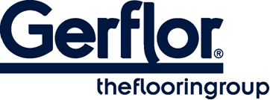 Attraction®

ATTRACTION® is a semi-flexible tile constructed by compacting, at high temperature and over 3000 T, a 4mm recycled backing and a 1mm pure vinyl wear layer.
This wear layer is incorporating very densely pressed coloured chips, with a mat finishing and without a transparent wear layer.

The product comprises a compact backing which is pressed and reinforced with two glass fibre grids.

ATTRACTION® has a unique dovetail joint which allows fast loose lay installation and replacement.

ATTRACTION® is treated with Protecsol®2, a surface treatment obtained by UV laser crosslinking. This Protecsol®2 ensures easy maintenance and eliminates permanently the need for acrylic emulsion (metallisation). It avoids staining of chemical products used in healthcare like iodine alcohol, Betadine, eosin and anti-bacterial hand gel.

It has a Bfl-s1 fire classification in accordance with standard EN 13501-1.

The products emission rate of volatile organic compounds is <10µg/m³ (TVOC after 28 days – ISO 16000-6).
It is made of 100% controlled recycled materials.
It does not contain any heavy metals or CMR 1&2 and they are 100% compliant with REACH.

It is 100% recyclable and made with up to 80% recycled content.

